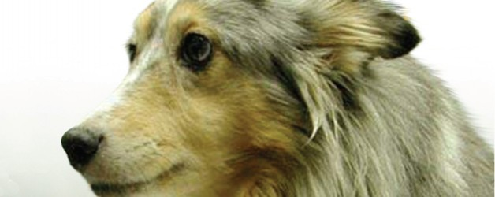
Fractures
NO  الاسبوع الاول  المحاضرةالاولى  المحاضرة الثانية | PAGE NO | CONTENTS
1 | 2 | Fracture Definition:
2 | 4 | Pathology Associated with Fracture
3 | 5 | Blood supply to long bone
4 | 6 | General consideration (principles)  of the fracture repair:
5 | 7 | Etiology of Fractures
6  الاسبوع الثاني  المحضرة الاولى  المحاضرة الثانية | 9 | Classification of Fractures
 | 10 | 1.Classification according to the degree of cortex disruption
 | 11 | 2. Classification according to communication through the skin between the fracture site and the outer environment:
 | 12 | 3. Classification of fracture by Location
 | 16 | 4. Classification according to the shape of the fracture line
 | 19 | 5. Classification according to the cause
 | 19 | 6. Classification according to the number of the bone fragments
 | 20 | 7. Classification according to the Stability of Fragment (Displacement).
 | 20 | 8. Classification according to degree of fracture severity
7 | 21 | Symptoms of the fractures
8 | 22 | DIAGNOSIS OF FRACTURE
9  الاسبوع الثالث  المحاضرة الاولى  المحاضرة الثانية | 23 | Principles of early management of fracture case .
10 | 24 | Fracture Treatment.
11 | 25 | Principle of the fracture healing:
12 | 25 | Types of fracture healing:
13 | 25 | STAGES OF FRACTURE HEALING
14 | 27 | Post-Operative Care
15 | 28 | Factors affecting fracture healing
16 | 30 | Complications of Fractures.

1. Fracture Definition:
A fracture is dissolution (break) of bony continuity with or without displacement of the fragments and may be complete or incomplete fracture. the cause mostly due to external trauma or force It is always accompanied by soft tissue damage of varying degrees , torn vessels, bruised muscles, lacerated periosteum, and contused nerves. Sometimes there are injury to the internal organs and lacerated skin.
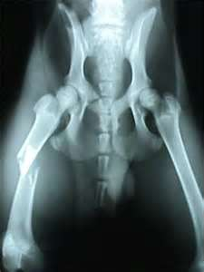
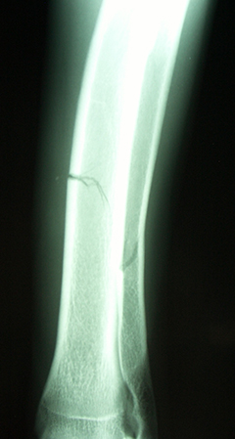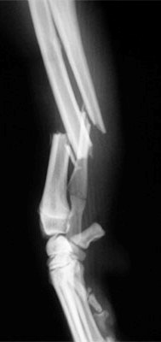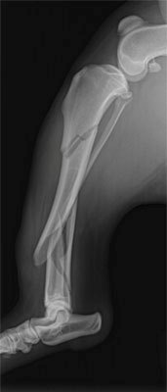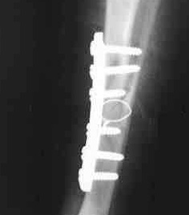

2. Pathology Associated with Fracture.
- Fractures have soft tissue injuries, and the trauma to soft tissue must always be more important than the fracture itself.
- Pelvic fracture may result in laceration of the bladder, prostate, pelvic urethra, or major vessels and nerves.
- Ribs Fractured routinely accompanies hemothorax, pneumothorax, or laceration of the lung parenchyma.
- Skeleton Fracture can be expected to compromise the brain, brain stem, or spinal cord. The brain or spinal cord may have contused within its bony case and become edematous.
- Trauma sufficient to cause fracture may also produce whole body manifestations.
- Automobile trauma can cause a fractured femur, the entire animal is involved and the likelihood of shock is great.
- Fat embolization from the fracture site may occur and produce respiratory difficulty.
- Hemorrhage at the fracture site may be minimal, but a ruptured abdominal organ may result in blood loss sufficient to cause death.
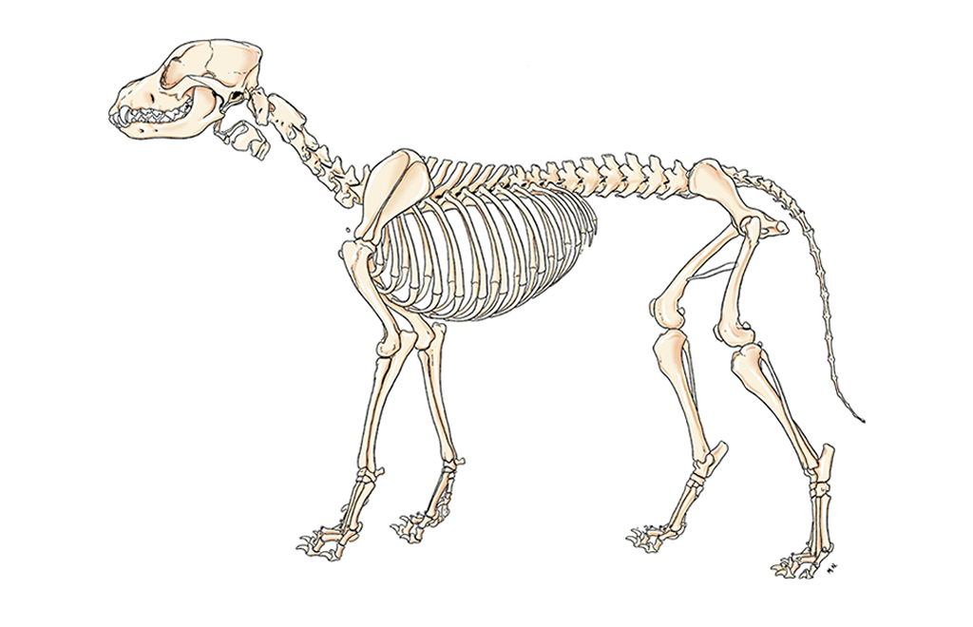

3. Blood supply to long bone:
- It is essential to have knowledge about the blood supply to the bone, and how it is affected by injury, and the different between the growing and a mature bone.
- 3 system of the vascular supply to the long bone.
- The nutrient system
- Enters the bone from the nutrient foramen and divided to ascending and descending branches.
- Supply 2/3 of the cortex from medulary marrow canal.
- Can anastomosis with other branches of the metaphyseal epiphyseal branches.
- The metaphyseal – epiphyseal system.
- Depend on the maturity of the bone and weather the growth plate present or not.
- Can anastomosis with other branches.
- The periosteal system.
- supply 1/3 of the cortex from outside the bone .it take its branches from
- Muscular attachment to the bone (fibrous layer of the periostums).
- No muscular attachment from the blood vessels passing over the bone.
- Role of blood supplying fracture healing is very essential ,so it is very important for :
- Carful exposure of blood vessels.
- Maintain the soft tissues attachment to the bone and fragments.
- The stripped periostum remain adjacent to bone during and after surgery.
- Extensive anastomosis network exit among the 3 vascular systems.

4. General consideration (principles) of the fracture repair:
- The surgeon should assist the nature, not attempt to substitute for it.
- The best treatment is to restore the function of the part and the patient in the shortest time with least damage and risk.
- Whatever the technique of the repair the following may be observed :
- The blood supply to the bone and fragments of bone must be preserved.
- Accurate restoration of bone counter is essential, especially when joints involved.
- The repair must be mechanically stable. ( to realignment
the bone and allow healing). The techniques that result in minimum trauma should be used.
- Controlled exercise should be allowed early.
- Treatment of the patient with a fractured bone does Involve:
- Accurate definition of the fracture and its complications and its types of fracture (Compound fractures in which the risk of Infection is high are treated differently than closed fractures).
- Age Of the patient Growing puppies may heal in as little as five weeks, and because of their size they put less weight on the bone. Therefore a fracture in a young puppy may be treated with a cast but the same fracture may need to be 'pinned' in which healing may take twelve weeks or more.
- Which bone is broken? Hairline fractures in long bone may only require rest, while surgical intervention will usually be needed in more severe fractures.
- The Signs of fracture which may be watched, and give more attention:
- Paralysis (nerve damage).
- Extreme weakness or depression (blood loss, bad appetite).
- Difficulty breathing (chest damage, difficulty in breathing).
- Abdominal discomfort or distention (abdominal damage).
- A change in mental status (brain damage, abnormal body temperature
5. ETIOLOGY OF FRACTURES
- Predisposing factors.
- Bone location.
- Old age.
- Ground (hard, slippery, smooth,).
- Bone inflammation (ostitis, osteoporosis).
- Bone diseases (osteomylitis, osteomalasia).
- Direct factors
1. Extrinsic Causes
1.Direct Violence
Trauma is the most common cause and is usually due to
- automobile injury
- Falling from a height.
- Animals fighting
- Most fractures are either comminuted or multiple.
2. Indirect Violence
A force is transmitted to a"weak link"of bone, causing a fracture.
- Bending Forces
Bending fractures occur when force is applied to a specific focal point on diaphysis. The cortical break opposite the site of the trauma. The periosteum will remain intact on the side of the force while tearing over the fracture on the opposite side. generally oblique or transverse, or they may have a butterfly fragment
- Torsional Forces
Torsional fractures occur when a twisting force is applied to the long axis of a bone. Generally result in short or long spiral fractures. with sharp points and edges
- Compression Forces
Compressive forces along the long axis of a bone may force the smaller diaphyseal or metaphyseal portion of a bone to impact into the larger epiphysis: bony is crushed. result in impacted fractures or compression fractures
- Shearing Forces
A shearing fracture is caused by a force transmitted along the axis of a bone, and then transferred to bone peripheral to the axis or across a joint to other bones. The fracture line will be parallel to the direction of the applied force.
2. Intrinsic Causes
1. Fractures due to Muscular Contraction
Fractures caused by violent contraction of a muscle are called avulsion fractures. Occur in immature animals while the physeal plate remains open. In, scapular tuberosity, greater humeral tubercle, olecranon, ischial tuberosity, greater trochanter, tibial tuberosity, and the calcaneus of the fibular tarsal bone.
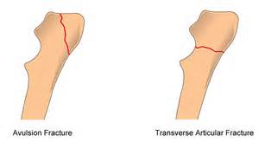

2. Pathologic Fractures or physiological fracture.

Pathological fractures occur when bone is weakened by a disease such as infection, malignancy or lack of nutrition. Spontaneous fractures occur when bone is so weakened that fracture may occur even by forces of daily use
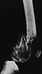  Pathologic fracture. Fibro sarcoma of the distal femoral metaphysis in a dog | .

6. Classification of Fractures:
1 | Classification according to the degree of cortex disruption | 1. Incomplete fracture:  1. Greenstick Fracture  2. Fissure Fracture  3. Depression Fracture  2. Complete fracture:  1. Transverse Fracture  2. Oblique Fracture  3. Spiral Fracture  4. Comminuted Fracture  5. Multiple Fractures  6. Impaction Fracture  7. Compression Fraction
2 | Classification according to communication through the skin between the fracture site and the outer environment | 1. Closed Fracture (simple fracture).  2. Open Fracture (compound fracture).
3 | Classification according to the anatomical location of the  Fracture within an individual bone | 1. Diaphyseal Fracture  2. Metaphseal Fracture  3. Epiphyseal Plate Fracture  4. Epiphyseal Fracture  5. Condylar Fracture  6. Ariticular Fracture (intra articular and extra articular)  (Fracture Dislocation).
4 | Classification according to the shape of the fracture line | 1. Transverse Fracture  2. Oblique Fracture  3. Longitudinal Fracture  4. Spiral Fracture  5. Multiple Fractures  6. Comminuted Fracture
5 | Classification according to the cause | 1. Traumatic Fracture (stress fracture).  2. Pathological Fracture  3. Physiological Fracture
6 | Classification according to the number of the bone fragments | 1. Simple Fracture  2. Comminuted Fracture  3. Multiple Fractures  4. Segmental fracture  5. Butter fly fracture
7 | Classification according to the Stability of Fragment (Displacement). | 1. Stable Fracture (Non Displaced Fracture).  2. Non Stable Fracture (Displaced Fracture).
8 | Classification according to degree of fracture severity | 1. Complicated Fracture.  2. Uncomplicated Fracture.

1. Classification according to the degree of cortex disruption
1. Incomplete Fractures.
An incomplete fracture implies that a bone has not completely lost continuity; some portion of the bone remains intact. There are several types of incomplete fractures.
Incomplete radial fracture in a dog.

1. Green Stick Fracture
In the immature animal bending force will produce the incomplete fracture. The bone cortex remains intact; this fracture cannot override and result in limb shortening
2. Fissure Fracture
Cracks or fissure lines will occur when direct trauma is applied to any long or flat bone. Generally the fissures are formed in one cortex of the bone and are covered by an intact periosteum.
3. Depression Fracture
Depression fractures represent multiple fissure fracture lines with sufficient force, the entire area will depress from the direction of force. In the calvarium, the maxilla, or the frontal bone areas of the head.

2. Complete Fractures
complete loss of bony continuity, allowing overriding and deformation.
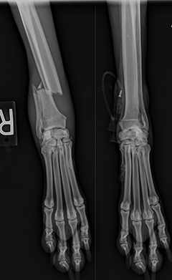
Complete fractures of the right radius and ulna of an adult dog.

2. Classification according to communication through the skin between the fracture site and the outer environment:

1. Closed Fracture. (Simple Fracture).
The fracture does not communicate with the outside environment. No wound or mucosal membrane overlies the fracture.

2. Open Fracture (Compound Fractures).
The open fracture, communicates with the outside environment. Of greatest significance is the potential for contamination of the fracture site.

3. Classification of Fracture by Location
1. Diaphyseal Fracture
For purposes of description, fractures are termed mid shaft if they occur near the axial center of the diaphysis. Therefore, fractures can be proximal third, middle third, or distal third of the diaphysis.
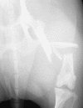
2. Metaphysical Fracture
Any fracture within the anatomical metaphysis of a long bone is referred to as a metaphysical fracture. For a clearer description the terms proximal or distal should be added, such as a closed, oblique fracture of the distal femoral metaphysis. Since most metaphyseal fractures are through cancellous bone, they generally heal rapidly.
3. Epiphyseal Plate Fracture
occurs in immature animals during the time that the epiphyseal plate remains open and cartilaginous. Fracture occurs through the zone of hypertrophied cartilage cells ( Salter- Harris is the standard classification for all species).
Type I-Epiphyseal separation: there is displacement of the epiphysis from the metaphysis at the growth plate.
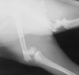
Type II-A small corner of metaphyseal bone fractures and displaces, with the epiphysis displaced from the metaphysis at the growth plate.
Type III-Fracture is through the epiphysis and part of the growth plate, but the metaphysis is unaffected.
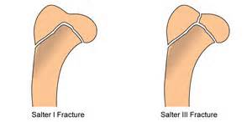
Type IV-Fracture is through the epiphysis, growth plate, and metaphysis. Several fracture lines may be seen.
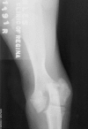
Type IV fracture of the lateral humeral condyle in a young puppy.
.
Type V-Impaction of the epiphyseal plate occurs, with the metaphysis driven into the epiphysis.

4.Physeal Fracture.
In the mature animal with closed growth plates they classified further by describing them as fractures of the proximal or distal epiphysis.
5. Condylar Fracture
Condylar fractures occur in mature animals and affect the distal ends of the humerus or femur, or the proximal tibia. Since anatomically a condyle is composed of metaphysis, physis, and epiphysis, This is a supracondylar/intercondylar fracture and classified as a "V," "Y," or "T".
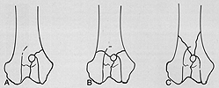
Condylar fractures. (A) Lateral humeral condyle fracture. (B) Intercondylar and supracondylar fractures of the distal humerus (a "T" fracture). (c) Intercondylar and supracondylar fractures of the distal humerus (a "Y~ fracture).
A lateral humeral condylar fracture | A lateral humeral condylar fracture with two screws

6. Articular Fracture (Fracture-Dislocation)
Articular fracture indicates that the subchondral bone and articular cartilage. Articular fracture is synonymous (intra-articular) fracture and means fracture within a joint. The term periarticular fracture (Extraarticular fractures) are those in which the fracture line does not enter the joint space. Fracture-dislocation describes joint fractures result subluxation or luxation, difficult to treat.

4. Classification according to the shape of the fracture line
1. Transverse Fracture
A fracture in which the break is across the bone, at a right angle to the long axis of the bone.
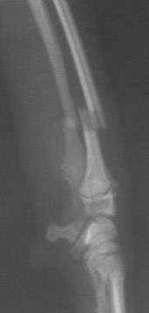  Distal radius and ulna fracture in a toy breed dog | 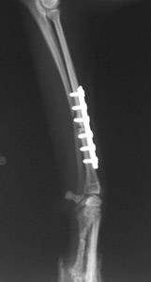Radius and ulna fracture repaired with a bone plate and screws
2. Oblique Fracture
Oblique fracture implies a fracture line that is oblique to the long axis of the bone. This fracture tends to override or rotate unless traction is maintained throughout the period of healing

3.Spiral Fracture
Spiral fracture indicates a fracture line that spirals along the long axis of the bone. These fractures tend to override and rotate into deformity. Easily confused with the oblique fracture. Instead of a straight break as in oblique fracture that is only in one plane, the break in this case traverses both the planes.
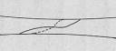

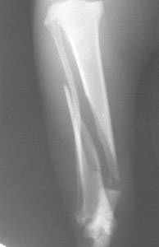  Fracture of the tibia (shinbone) in a cat | 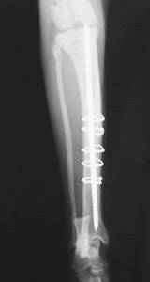  Repair of the tibial fracture with a pin and five wires
4. Comminuted Fracture
Comminuted fracture implies at least three fracture fragments, the fracture lines of which interconnect. The fracture lines may be transverse, oblique, or spiral, and difficult to reduce and
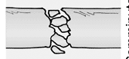

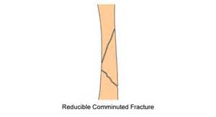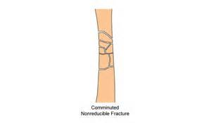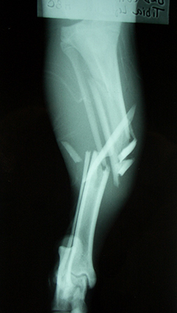
A comminuted tibial fracture of an adult dog.
5. Multiple Fracture
Multiple fractures implies three or more fracture fragments in a single bone; fracture lines do not interconnect. may be of any shape.
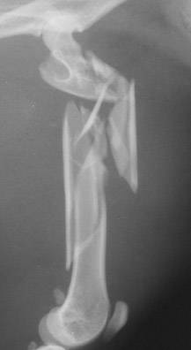A severe fracture of the femur (thigh bone) in a cat | 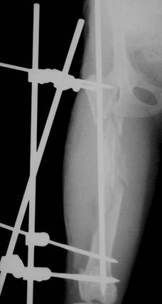Stabilization of the fracture using a pin and external skeletal
6. Impacted Fracture
An impacted fracture implies a fracture in which a bony fragment, generally cortical, is forced or impacted into cancellous bone. Typically this occurs at the ends of long bones. This is an uncommon fracture in small animals. This is a fracture in which the ends are driven into each other. Cancellous bone is typically involved, and union often occurs rapidly.

7. Compression Fracture.

This occurs in cancellous bone, It typically occurs in the vertebral bodies. These fractures are stable and heal in place; however, shortening occurs as a result of compression.
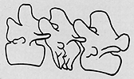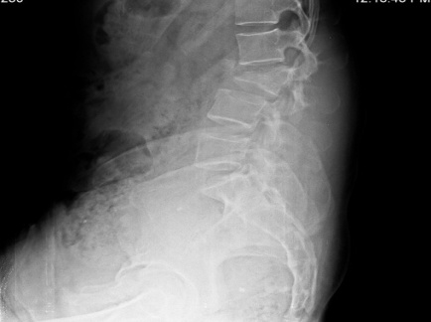

Compression fracture of a lumbar vertebral body.

8. Longitudinal Fracture

5. Classification according to the cause 1. Traumatic Fracture (stress fracture).
type of fractures which occur with repetitive of exposure of the normal bone to the forces. not a weakened by any pathology.

2. Pathological Fracture
Pathological fractures occur when bone is weakened by a disease such as infection, malignancy or lack of nutrition

3. Physiological Fracture
insufficient fractures. Osteoporosis is an age related loss of bone mineral and microarchitectural change in bone.

6. Classification according to the number of the bone fragments
1. Simple Fracture
2. Cominuted Fracture
3. Mulitible Fracture
4. Segmental
The bone is fractured at two distinct levels. Reduction of this fracture is difficult and nonunion common as seen in following x-ray.
5. Butterfly fragment
Butterfly fragment is a popular term for a wedge-shaped fragment of bone split from the main fragments,
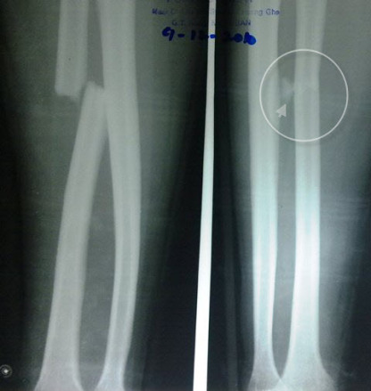
Segmental Fracture Fibula Butterfly fragment in fracture radius
with Fracture Tibia
7. Classification according to the Stability of Fragment (Displacement). Fracture can be displaced or undisplaced.
- Stable Fracture (Non Displaced Fracture).
The bone fragments stay together maintaining structural alignment of the bone , it is called an undisplaced fracture. A hairline fracture is an example of an undisplaced fracture.
- Non Stable Fracture (Displaced Fracture).
Fragment of the bone may move from their original position resulting separation of the fragments. Such a fracture is called a displaced fracture.
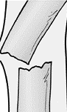
Stable Fracture Non Stable Fracture
8. Classification according to degree of fracture severity
1. Complicated FractureThere is significant soft tissue damage to (nerves, vessels, ligaments, and muscles).
2. Uncomplicated Fractureinvolve only minimal soft tissue damage.
7. Symptoms of the fractures:
- Swelling , Immediately after injury the swelling may be sharply outlined as a result of bleeding from the bone and the soft parts Generally the swelling increases for 24 to 48 hours, then gradually subsides (particularly under treatment). When applying bandages and splints immediately following fracture
- Deformity a deviation from the normal anatomical structure may be caused by displacement of the bony framework as in a fracture or dislocation, but it may also be caused by changes in configuration due to a neoplasm. If in doubt about positioning, comparison with the opposite limb or side of the body part is advised.
- Pain in the injured area when moved or pressure is applied. If an animal is examined during the state of local tissue shock, that is, within 20 to 30 minutes after the accident, pain may not be a conspicuous sign.
- Crepitating bone sound on palpation and examination.

- Dysfunction .Loss of function in the injured area, a broken back may displace the spinal cord and cause complete paralysis.

- Bone protruding from the skin in open fractures.

- Hold the entire leg off the ground; no weight is placed on affected limb. With a sprain or lesser injury, it may use the leg somewhat, but walk with a limp.

- Abnormal Mobility It occurs if there is a complete fracture of the shaft of a long bone; it does not occur in an incomplete or impacted fracture. Mobility near a joint may be difficult to differentiate from normal or abnormal mobility of the joint itself.

- Fever. Elevated temperatures are seen routinely 24 to 48 hours following a fracture and due to breakdown of the hematoma.

- Anemia. Large dogs may lose 200 ml to 300 ml of blood into the hematoma. Animals with multiple bone fractures can lose this amount of blood into each hematoma.

8. DIAGNOSIS OF FRACTURE
Diagnostic tests that may be needed to recognize and treat fractures include:
- Complete medical history (case history).
- Physical examination (crepitating sound of fracture ends during palpation).
- clinical signs( swelling ,lameness ,hold the affected limb).
- Radiographs (X-rays) of the affected limb :
- Two vertical views.
- To determine the, shape direction location and severity of line fracture.
- Radiographs of Chest and abdominal to rule out obvious organ injury
- Blood tests to evaluate for systemic organ trauma and diseases or consequences of shock:
- CBC. (Presence of anemia or other problems related to shock).
- Blood gas and electrolyte tests to evaluate the metabolic status.
- Uine anylsis(ureaprotein, albuminurea, lipurea).
- Blood chemistry look at the function of major organs, such as the liver and kidneys

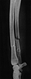
Radiographic signs of fracture. Note a radiolucency fracture line, and of radiopacity fracture line where fragments are superimposed.
9. Principles of early management of fracture case.
- Case history and animal examination:
- Animal description ,address , statues ,sex,previous treatment,
last treatment
- Clinical signs (lameness, swelling, hold the affected limb,
deformity).
- Physical examination body temperature respiratory and heart
condition.
- Labe test
- Blood sample for CBC and differential count , Biochemical analysis
- Urine analysis (BUN, creatinine).
- Stool examination (for internal parasites).
- ECG
- Sonar (pregnancy detection).
- X-ray detection for chest and abdominal evaluation.
- Save the life: the first consideration is the patient life
- Treatment shock (anti-inflammatory drugs, pain relief, and
Stop hemorrhage).
- Comfort the animal using narcotic or analgesia
- blood and fluid transfusion
- Tracheotomy (to provide ventilation to the lungs).
- Casting the animal ( temporary fixation to prevent improper
movement to avoid more tissues damage
- Refunction of the affected part quickly with less amount of risk.
(Repair of tissues).by open or closed reduction using fixation methods
- pre operative preparation:
- preanesthetic evaluation (by relieve pain, and induction of
Muscular relaxation).
- Preoperative preparation of the patient.
- Postoperative management of the repaired fracture and patient
using systemic antibiotics.
- Post operative treatment:
- X-ray radiography for proper bone and device position
- Daily checking the site of operation.
- Remove the suture materials 7-10 days post operation.
- Special consideration for the place and food.

10. Fractures Treatment :

- Reduction of fractured bone
- Closed reduction ,using external fixation methods
- Open reduction, using internal fixation methods.

- Approximate normal position ( re alignment ) : - It should be done
as soon as possible before pain, spasm, and swelling, as pain
Causes muscular Spasm. Using muscle relaxant drugs,manul
Retraction, extender with general anesthesia) until muscle fatigue.

- Immobilization using
- External splints (cooptation splints ,air cast , Plaster of Paris,
Mason meta splints, half pins splints, and modified Thomas splint).
- Internal splints (intramedullary pins,intramadullary pins with
interloaged screw compression bone plate With screw, screw,
and wire circlage,).
- Mixed methods (intramedullary pinning with plaster of Paris).

11. Principle of the fracture healing:

Provide adequate blood circulation.

Good alignment of the fractures fragment.

Proper immobilization

Give rest to the affected parts

Gradually training to promote revascularization and

Prevent muscular atrophy

12.Types of fracture (bone) union:
- Direct fracture (bone) union (primary fracture (bone) union).
Healing by osteoids formation of haversain system especially in
flat bone,without or less callus formation ,with no micro movement,
wih rigid fixation
- With contact healing (no gap) with rigid fixation
(Compression bone plate with screw).
- With gap healing with rigid fixation
(Compression bone plate with screw).
- Indirect fracture (bone) union (secondary fracture (bone) union.
Healing by callus formation with micro movement (intramedullary pins).

13. STAGES OF FRACTURE HEALING
1. Inflammatory phase
2. Reparative, phase.
3. Remodeling phase.
1. INFLAMMATORY PHASE
- After indication a fracture, the bone itself is damaged the soft tissue, and numerous blood vessels which crossing the fracture.
- There is an accumulation of hematoma
- This blood rapidly coagulates to form a clot.
- Osteocytes are die, at the ends of a fracture . Severely damaged soft tissues may contribute necrotic material to the region.
- The necrotic material elicits an acute inflammatory response.
- There is wide spread vasodilatation and plasma exudation, leading to the acute edema seen in the region of a fresh fracture.
- Acute inflammatory cells migrate to the region, as do polymorphonuclear leukocytes followed by macrophages.
As the acute response subsides, the second phase begins.
2. REPARATIVE PHASE
- The hematoma is organized, probably plays a very small mechanical role in immobilizing the fracture and serves primarily as a fibrin scaffold over which repair cells perform their function.
- The pH at the fracture is acid, which stimulus cell behavior gradually returns to neutral and then to a slightly alkaline level.
- The cells involved are of mesenchymal origin, cells probably of common origin form collagen, cartilage, and bone.
- The cells enter the fracture site from surrounding vessels.
- increased vascular bed .

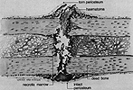 | The initial events involved in fracture healing of long bone The periosteum is torn opposite the point of impact and, in many instances. There is an accumulation of hematoma beneath the periosteum and between the fracture ends There is necrotic marrow and dead bone close to the fracture line.

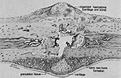 | Early repair. There is organization of the hematoma, early primary new bone formation in subperiosteal regions, and cartilage formation in other areas.
- The cells invade the hematoma and begin rapidly to produce the tissue known as callus, which is made up of fibrous tissue, cartilage, and young, immature fiber bone. This quickly envelopes the bone ends and leads to a gradual increase in stability of the fracture fragments. Variations in oxygen tension undoubtedly lead to the formation of either bone or cartilage, with cartilage being formed in areas in which oxygen tensions are relatively lowLater, bone formation is more obvious.
- The biochemical events: high level of glycosaminoglycans present early ,followed by a gradual increase in concentration collagen,
- With accumulation of calcium hydroxyapatite crystals occurring as a third stage Mineralized tissues are highly organized in their internal structure. Collagen fibrils have been called hole zones, they occur in regular fashion
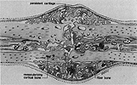 at later stage in the repair, early immature fiber bone is bridging the fracture gap. Persistent cartilage is seen at points most distant from in growing capillary buds. In many instances, surrounded by young new bone
- The result is organized collagen fibrils within and around which are clustered crystals of calcium hydroxyapatite.
- The bone ends gradually become enveloped in a fusiform mass of callus containing increasing amounts of bone.
- Immobilization becomes more and eventually clinical "union" is said to have occurred.
3. REMODELING PHASE:
- The remodeling phase begins with resorption of unneeded of the callus and the laying down of trabecular bone along lines of stress (replaced the woven bone with lamellar bone).
- The cellular module that controls remodeling is the resorption unit, consisting of osteoclasts, which first resorb bone, followed by osteoblasts, which lay down new haversian systems.
- The end result of remodeling is a bone of original form.
14. Post-Operative Care:
- Daily checking the site of operation.
- Daily injection antibiotics for 3-5 days post operation.
- Keeping the animal from licking at the surgical incision is imperative ( ضروري) , at least until the sutures are removed. Persistent licking at a surgical wound will delay healing and is the major cause of incision infections.
- Pain Control (pain relief), especially during the in-hospital period. Watch for signs of pain by observing whether the pet is able to settle down, rest, and sleep. Animals in chronic pain have difficulty getting comfortable and will be reluctant ( ممانعُ ) to sleep for normal periods.
- Watch the limb for signs of swelling, redness, or discharge at the surgery site.
- Monitor the pet’s appetite and changes in the use of the limb.

15. Factors affecting fracture healing
1- Age: - The younger the age the faster the healing

2- Individual variation.

3- Nutrition: - Qualitative or quantitative reduction in food ingredients prolongs healing time.

4- Cause: - Traumatic injuries is characterized by temporary hematoma followed by rapid healing, while infection of fracture site causes destruction of the granulation tissue with prolongation of healing time.

5- Site of fracture: - Epiphysis fracture of spongy bone heals faster than fracture of compact bone.

6- Shape of fracture: - Oblique or longitudinal fracture is better than transverse fracture, also single smooth fracture is better than multiple fragmented granulated fracture.

7- Non union and delayed union of fracture.

8- Wide separation.

9- Incarcerating of soft tissue between fragments.

10- Some diseases (rickets or osteomalasia).

11- Infection or osteomylitis.

12- Steroidal drugs affect on the fracture healing.

13- Sex of the animal: - Female fractures have better prognosis than male fracture due to quietness of the female.

14- Duration: - The more recent fracture the better the prognosis.

15- Complications: - non-infected Simple fracture has better prognosis.

16. Complications of Fractures.

1. Early (acute) complication Fractures
- Shock.
Hypovolemic shock can readily occur with severe fracture and vascular lacerations may lead to death.
- Nerve injury.
Depending on the location of the fracture or its severity, peripheral nerves can be involved.
- Necrosis or gangrene.
Vascular laceration or occlusion, and necrosis of distal extremities may occur. This usually occurs several days following fracture.
- Fat in synovial fluid.
This sign may indicate presence of an articular fracture; however, any trauma to a joint may result in fat in the synovial fluid. If fat is found and the animal remains lame, further studies may be needed to pursue the diagnosis of fracture.

Compartment Syndrome.

acute problem following injury which increased pressure within a confined space in the limb impairs blood supply resulting in ischemia.

Infection.

Infection can occur by three rots
- The fracture is open and wound gets infected by organism.
- The fracture hematoma can get infected from bloodstream.
- Post surgical infection
limited and superficial infection ,need cleaning and antibiotics. Drainage of pus, debridement of necrotic tissues, irrigation of the wound used in case of deep infections. Uncontrolled infection can lead to septic arthritis and osteomyelitis.

Fracture Blisters .

Occur where skin adheres tightly to bone with little intervening soft tissue cushioning. Examples include the ankle, wrist, elbow and foot. result from large strains applied to the skin during the initial fracture deformation, and they resemble second-degree burns rather than friction blisters. Blisters alter management and repair, often necessitating early cast removal and immobilization by bed rest with limb elevation.

2. Late (chronic) complication Fractures.
- Delayed union is failure of a fracture to consolidate within the expected time. Healing processes are still continuing, but the outcome is uncertain.
- Non-union occurs when there are no signs of healing after 3-6 months (depending upon the site of fracture).
- Malunion refers to union of fracture in unsatisfactory position.
- Joint stiffness.

Myositis ossificans.
Myositis ossificans involves calcifications and bony mass formation within muscle and can occur as a complication of fractures, especially in supracondylar fractures of the humerus. Rest, NSAIDs may be helpful.

Iatrogenic Complications of Fractures.
Pressure ulcers due to cast, thrombophlebitis due to stasis following immobilization or plaster application. Nerve injury, vessels injury can occur during to surgery. Pin tract infection can occur in case of external fixation.

- Osteomyelitis.infection of the bone and the bone marrow by micro organism
.

